Presentation: Emotional Body Armor for First Responders
National Keynote Speaker: Sean Riley, Safe Call Now

Multiple Attendance Options:
September 28, 2017 from 12:00 p.m. to 2:00 p.m.
September 28, 2017 from 4:00 p.m. to 6:00 p.m.
September 29, 2017 from 9:00 a.m. to 11:00 a.m.
September 29, from 1:00 p.m. to 3:00 p.m.
This free training focuses on mental wellness and self-care for the first responder and is CLEET approved for the two hour mental health yearly requirement. CEUS offered for clinical staff.
Presentation will be held at the Education Center: 901 N. Porter Ave., PO Box 1308, Norman, OK 73071.

RSVP to cathywahkinney@spsh.com
For Questions: Cathy Wahkinney 405-481-0701
SPONSORED BY:
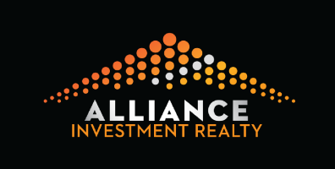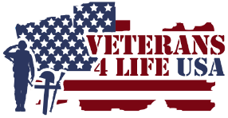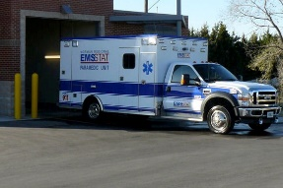
"This class has been accredited by the Council on Law Enforcement Education and Training for 2 hours of mandatory continuing education credit. Regarding any law enforcement concepts, practices, methods, techniques, products or devices as might be taught, promoted, or otherwise espoused in outside schools or seminars, there is no intent, expressed or implied, that 'accreditation' indicates or in any way conveys 'CLEET approval' of such concepts, practices, methods, techniques, products or devices, unless such approval is explicitly stated by CLEET."

