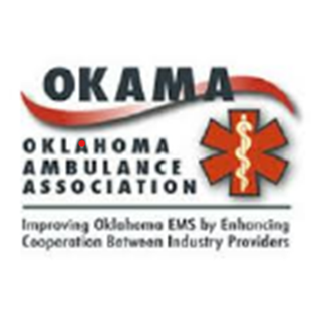
A few months ago, OKAMA submitted a Request to the State of Oklahoma asking for a portion of the Coronavirus Aid, Relief and Economic Security (CARES) funds that were allocated to the state by the federal government. Our research, data, and analysis were compiled into a comprehensive Request document. Our plea was that our professional, dedicated providers were suffering under the demands created by the pandemic and needing financial assistance to help them manage the effects.
OKAMA is pleased and proud to announce that our efforts have resulted in at least $5,000,000 award to be distributed to all licensed ambulance services that provide ground emergency medical transportation in our state. Our request was based on a fair and equitable method of awarding and equal amount, approximately $ 6,200 for every Permitted Transport Ambulance operated by the licensed ambulance service. It is possible that the committee that made this award will find additional funds soon. We wanted to let you know as soon as we could that there is at least some award headed to you.
The Oklahoma Ambulance Association, OKAMA, has long advocated for our Oklahoma EMS and Ambulance Services. Since 2002, we have worked countless hours to promote communication, understanding and advances for EMS in our state and the ability of our EMS to provide the best possible service to the communities. While we have a dedicated group of Members, we work to represent the interests of all providers as a collective and look to benefit as many of the Ambulance services as possible.
The efforts of so many are so appreciated. But what we accomplished was in large part thanks to our Legislative Liaison, Margaret Erling. Her skill, network, and her appreciation for Okla. EMS worked for us. At one point, we were out of consideration and she got us back in. We owe a lot of this success to her.
These are federal funds that must be spent in such a way that complies with the federal requirements outlined in the act. OKAMA is confident that all licensed services will have expenses in the period of March 1, 2020 through December 30, 2020. By accepting these funds, you will agree to make available documentation of expense of funds that proves qualification to receive these funds.
We have attached documents to this email. The first is the document OKAMA submitted as a basis for our request. The second is a portion of the Federal guidance of what expenses qualify and what expenses will not. OKAMA’s Request was based on the following;
- EMS/GEMT have experienced increased expense directly related to the pandemic due to increased need for Personal Protective Equipment, PPE. Our evidence stated that EMS was now having to use more masks, gowns and gloves to protect personnel from potentially infectious and confirmed infectious patients.
- Expense for personnel that missed work due to COVID infection, isolation, or quarantine, but were paid while away.
- Expense for personnel that covered the absence of sick, quarantined or isolated employees
- Expense for increased staffing to meet local requirements, expectations, operational objectives.
- Expense related to increased use of supplies (oxygen, drugs, other non-PPE supplies) as patient transports showed increased acuity (sicker patients) and increased frequency.
- Expenses related to increased cost for both PPE and other supplies as demand increased and decreased available supplies. Price increases.
- Expenses related increased costs of the decontamination of ambulances, equipment, personnel and stations.
- Expense related to responding, providing care, and transporting an increased number of patients that have no or inadequate healthcare coverage due to loss of employment or work.
As you can see, several experiences that we learned are common to nearly all our EMS/GEMT providers. The list is not all-inclusive to your expenses and experience, but we believe that all of the experiences listed will qualify under the government’s description of qualifying expenses. You should expect, as with all grants of government funds, your expenditures to qualify are subject to review and audit. We want you to be prepared.
OKAMA wants to be a resource for any questions you might have about compliance with the limited requirements to receive this fund. Please contact us. We may have an answer that we already researched for another EMS. If not, we will call on our resources to get an answer if it exists. Again, we are here to help.

OKAMA Board of Directors
December 20, 2020

